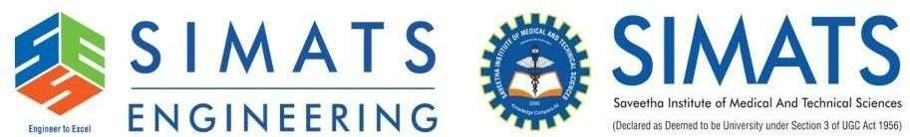

CSA0501 – DATABASE MANAGEMENT SYSTEM CO-1 AT-3

PRESENTED BY:
G.Chakradhar(192311439)
GUIDED BY:
Dr. A. JAYA MABEL RANI



Question 1 - Introduction to DBMS

What is a DBMS?
A Database Management System (DBMS) is software that enables users to create, store, organize, retrieve, update, and manage data efficiently. It acts as an interface between users, applications, and databases, ensuring data is stored securely and accessed quickly.

Features
- Stores and organizes large volumes of data
- Supports Create, Read, Update, and Delete (CRUD) operations
- Reduces data redundancy and inconsistency
- Provides security and controlled access
- Supports multiple users simultaneously

Examples
- MySQL
- Oracle Database



Question 1 - Objectives of DBMS

Objectives of a DBMS
The main objective of a DBMS is to efficiently manage data while maintaining accuracy, security, and
reliability.

Objectives
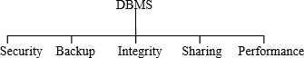
- Minimize data redundancy
- Maintain data consistency
- Ensure data security and privacy
- Provide data sharing among multiple users
- Support backup and recovery
- Maintain data integrity
- Improve data access speed
- Simplify database management



Question 1 - Advantages of DBMS

- A DBMS provides several benefits compared to traditional file-based systems.

Advantages
- Centralized data management
- Reduced duplicate data
- Faster data retrieval
- Improved data accuracy
- Better security with authentication
- Backup and recovery facilities
- Concurrent access for multiple users
- Easy maintenance and scalability

Example
Without DBMS
- Different departments maintain separate student records.
- Duplicate information and inconsistent data occur.

With DBMS
- A single centralized database is shared.
- Data remains accurate and consistent.



Question 1 - Real-World Applications of DBMS

Applications
DBMS is widely used in organizations to manage large amounts of information efficiently.

Industry | Application
🏦 Banking | Customer accounts, transactions, ATM services
🏥 Healthcare | Patient records, appointments, medical history
➵ Education | Student records, attendance, examinations
🛒 E-Commerce | Products, customers, orders, payments
✈ Airline | Flight booking and reservation systems
📱 Social Media | User profiles, posts, messaging
📦 Inventory | Product stock and warehouse  management



Question 1 - Summary and Importance of DBMS

Why is DBMS Important?
DBMS plays a vital role in modern information systems by ensuring that data is stored, managed, and
retrieved efficiently
.

Key Takeaways
- Organizes and manages data efficiently
- Improves security and data integrity
- Reduces redundancy and inconsistency
- Supports multiple users simultaneously
- Enables fast and reliable data retrieval
- Widely used in business, education, healthcare, banking, and e-commerce

Conclusion
A Database Management System (DBMS) is the backbone of modern data management. It provides secure, efficient, and reliable data storage, making it an essential component of almost every digital application.



Question 2 - File-Based System vs DBMS

Comparison Between File-Based System and Database Management System (DBMS)
- A File-Based System stores data in separate files, making it difficult to share, update, and
maintain information.
- A Database Management System (DBMS) stores data in a centralized database, ensuring
better security, consistency, and efficient data management.

Real-Life Example: Banking System

Without DBMS (File-Based System):
Customer information is stored in separate files for savings, loans, and ATM services.
Updating one file does not update the others, causing duplicate and inconsistent data.

With DBMS:
All customer information is stored in one centralized database.
Any update is reflected across all banking services instantly, improving accuracy and reducing
redundancy.



Question 2 - File-Based System vs DBMS

File-Based System | Database Management System (DBMS)
Data stored in separate files | Data stored in a centralized database
High data redundancy | Minimal data redundancy
Difficult to share data | Easy data sharing among users
Limited security | Strong security and access control
No backup and recovery | Automatic backup and recovery
Data inconsistency may occur | Maintains data consistency
Slower data retrieval | Faster data retrieval using SQL
Suitable for small applications | Suitable for large organizations



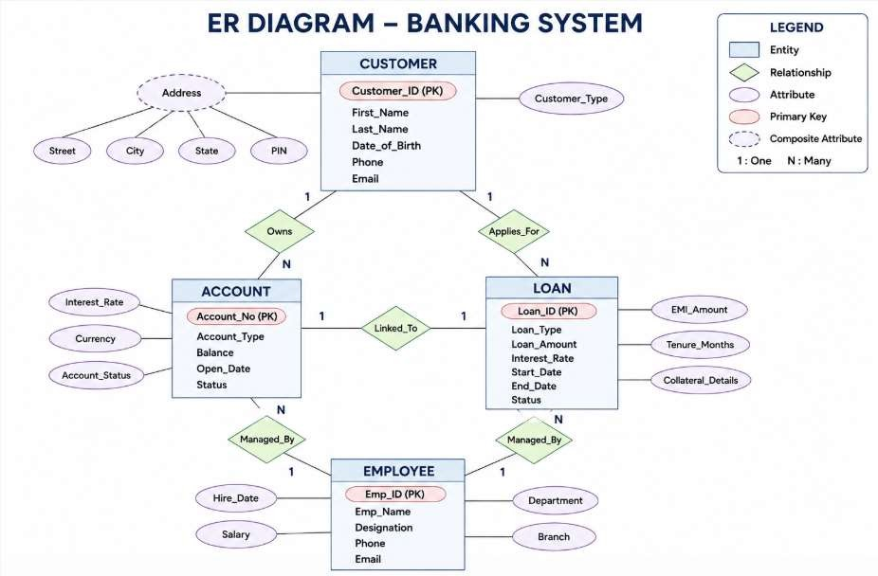
Question 2 - File-Based System vs DBMS



Question 3 - ANSI/SPARC Three-Level Architecture

ANSI/SPARC Three-Level Architecture
The ANSI/SPARC Three-Level Architecture is a standard database architecture that separates the database into three levels. This separation provides data independence, improves security, and allows users to view only the data they need.

Three Levels
- External Level (View Level)

Conceptual Level (Logical Level)
- Internal Level (Physical Level)

External Level (View Level)
    - The highest level of the architecture.
    - Different users see different views of the same database.
    - Improves security by hiding unnecessary data.
Example: A student can view only their marks and profile.



Question 3 - ANSI/SPARC Three-Level Architecture

Conceptual Level (Logical Level)
    - Describes the complete logical structure of the database.
    - Defines entities, relationships, constraints, and attributes.
    - Independent of physical storage.
Example: Student, Course, Faculty, and Enrollment tables.

Internal Level (Physical Level)
    - Lowest level of the architecture.
    - Describes how data is physically stored.
    - Includes files, indexes, storage blocks, and memory management.
Example: Data stored on SSD/HDD using B+ Trees and indexes.

Advantages
Provides Logical and Physical Data Independence.
Supports Multiple User Views.
Simplifies Database Maintenance.



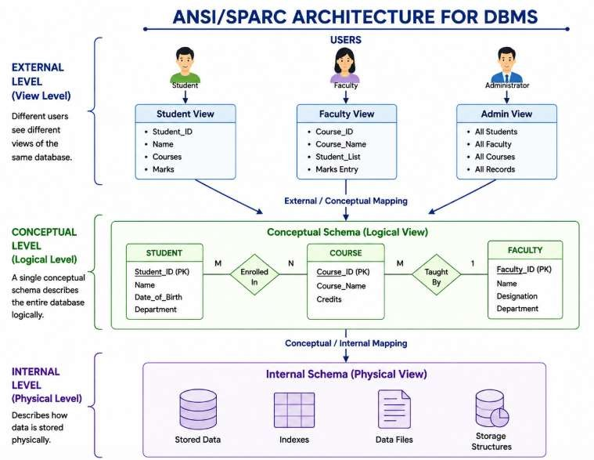
Question 2 - File-Based System vs DBMS



Question 4 - Different Data Models in DBMS

Different Data Models in DBMS
A Data Model is a method used to organize, store, and represent data in a database. It defines how data is
connected and how users can access it.

Hierarchical Data Model
  - Organizes data in a tree-like structure.
  - Each child has only one parent.
  - Supports one-to-many (1:N) relationships.
  - Fast for simple hierarchical data.
Example: Company Organization Chart, File System

Network Data Model
  - Organizes data using a graph structure.
  - A child can have multiple parents.
  - Supports many-to-many (M:N) relationships.
  - More flexible than the hierarchical model.
Example: Airline Reservation System, Telecommunications



Question 4 - Different Data Models in DBMS

Relational Data Model
  - Stores data in tables (rows and columns).
  - Tables are connected using Primary Keys and Foreign Keys.
  - Easy to manage using SQL.
  - Most widely used database model.
Example: Banking System, Hospital Management, Library Management

Comparison

Model | Structure | Relationship | Example
Hierarchical | Tree | 1:N | File System
Network | Graph | M:N | Airline Reservation
Relational | Tables | PK & FK | Banking System



Question 4 - Different Data Models in DBMS

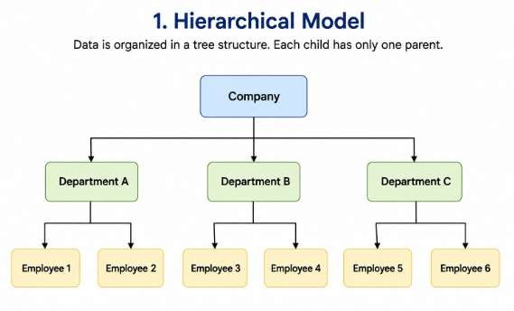
Hierarchical Model 2. Network Model
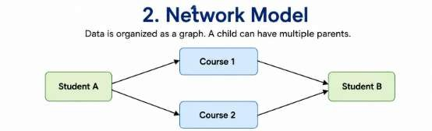

3. Relational Model
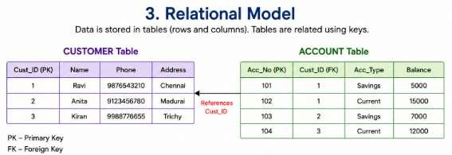



Question 5 - ER Diagram for Online Library System

Online Library System – ER Diagram
An Entity Relationship (ER) Diagram is a graphical representation of the entities, attributes, and relationships in a database. In an Online Library System, it helps organize books, members, librarians, and borrowing records efficiently.

Main Entities

Advantages
- Reduces duplicate data.
- Maintains accurate borrowing records.
- Makes book searching easier.
- Improves library management
  - Member – Stores library user details.
  - Book – Stores information about books.
  - Librarian – Manages books and members.
  - Issue – Records book issue and return details.
  - ​

Relationships
  - A Member can borrow many Books.
  - A Book can be issued many times.
  - A Librarian manages book issuing and returns.
  - The Issue entity connects Members and Books.
.



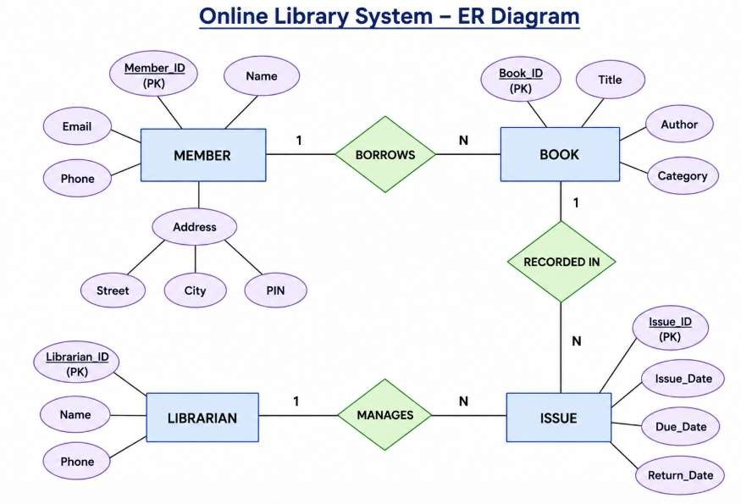
Question 4 - Different Data Models in DBMS

Advantages
- Reduces duplicate data.
- Maintains accurate borrowing records.
- Makes book searching easier.
- Improves library management



Question 6 - EER Model with University Case Study

Enhanced Entity Relationship (EER) Model
The Enhanced Entity Relationship (EER) Model is an advanced version of the ER model. It introduces Generalization and Specialization, making it easier to represent complex real-world systems.

Generalization
  - Combines similar entities into one general entity (Superclass).
  - Represents common attributes shared by multiple entities.
Example:
  - Student and Faculty are combined into a Person entity.

Specialization
  - Divides one general entity into specialized entities.
  - Each specialized entity has its own unique attributes.



Question 6 - EER Model with University Case Study

Example:
  - Person is divided into:
  - Student
  - Faculty

University Case Study
  - Person stores common information such as Person_ID, Name, Email.
  - Student stores Roll Number, Course.
  - Faculty stores Employee ID, Department.

Advantages
  - Reduces data redundancy.
  - Improves database organization.
  - Supports inheritance.
  - Simplifies complex database design.



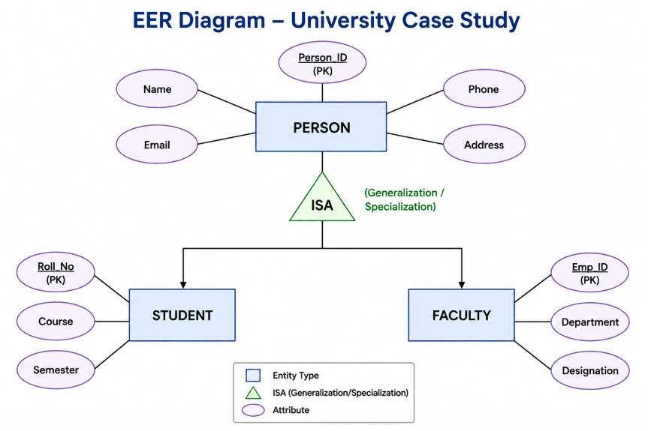
Question 4 - ER Diagram for Online Library System



Question 7- Data Independence in DBMS

Data Independence in DBMS
Data Independence is the ability to modify the database schema at one level without affecting the schema at the next higher level. It allows changes to the database without changing application programs.

Types of Data Independence
- Physical Data Independence
  - Changes are made at the Internal (Physical) Level.
  - Does not affect the Conceptual or External Level.
  - Improves storage performance without changing the database design. Examples
  - Changing file organization.
  - Adding indexes.
  - Moving data from HDD to SSD.



Question 7- Data Independence in DBMS

Logical Data Independence
  - Changes are made at the Conceptual (Logical) Level.
  - Does not affect the External (View) Level.
  - Allows modifications to the database structure.

Examples
  - Adding a new table.
  - Adding a new attribute.
  - Splitting a table into two tables.

Significance
  - Reduces application maintenance.
  - Improves database flexibility.
  - Makes database upgrades easier.
  - Provides better scalability.
  - Enhances system performance.



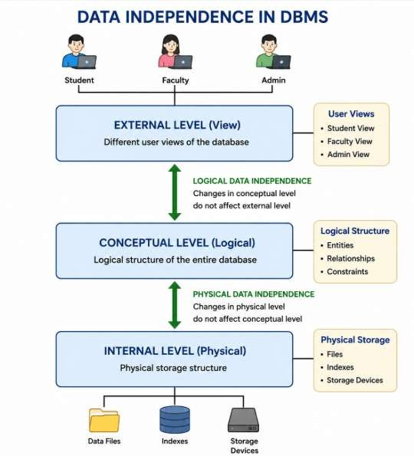
Question 7- Data Independence in DBMS



Question 8- Software Components of DBMS

A Database Management System (DBMS) consists of several software components that work
together to process, store, and manage data efficiently.

Query Processor
  - Accepts SQL queries from users.
  - Checks the query for errors.
  - Optimizes the query for faster execution.
  - Retrieves the required data from the database.

Example:
SELECT * FROM Student;

Storage Manager
  - Manages how data is stored on the disk.
  - Handles files, indexes, and buffers.
  - Retrieves and updates data efficiently.
  - Ensures proper use of storage space.



Question 8- Software Components of DBMS

Transaction Manager
  - Controls database transactions.
  - Maintains ACID properties.
  - Prevents data loss during failures.
  - Supports multiple users simultaneously.

Example:
Bank money transfer between two accounts.

Importance
  - Faster query execution.
  - Secure and reliable data storage.
  - Maintains data consistency.
  - Improves overall database performance.



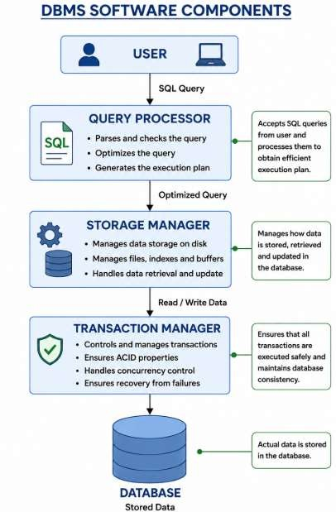
Question 8- Software Components of DBMS



Question 9- Strong Entity vs Weak Entity
In an ER Model, entities are classified as Strong Entities and Weak Entities based on whether they can be uniquely identified.

Strong Entity
A Strong Entity has its own Primary Key and can exist independently.

Characteristics
  - Has its own Primary Key (PK)
  - Can exist without another entity
  - Represented by a single rectangle
Example Student Employee Customer Book



Weak Entity

Question 9- Strong Entity vs Weak Entity

A Weak Entity does not have its own complete Primary Key. It depends on a Strong Entity for
identification.

Characteristics

- Depends on a Strong Entity
- Uses a Partial Key
- Represented by a double rectangle
- Connected by a double diamond (Identifying Relationship)

Example
- Order Item depends on Order
- Dependent depends on Employee
- Book Copy depends on Book

Strong Entity | Weak Entity
Has Primary Key | Has Partial Key
Exists independently | Depends on Strong Entity
Single Rectangle | Double Rectangle
Example: Employee | Example: Dependent



Question 9- Strong Entity vs Weak Entity
In an ER Model, entities are classified as Strong Entities and Weak Entities based on whether they can be uniquely identified.

Strong Entity
A Strong Entity has its own Primary Key and can exist independently.

Characteristics
  - Has its own Primary Key (PK)
  - Can exist without another entity
  - Represented by a single rectangle
Example Student Employee Customer Book



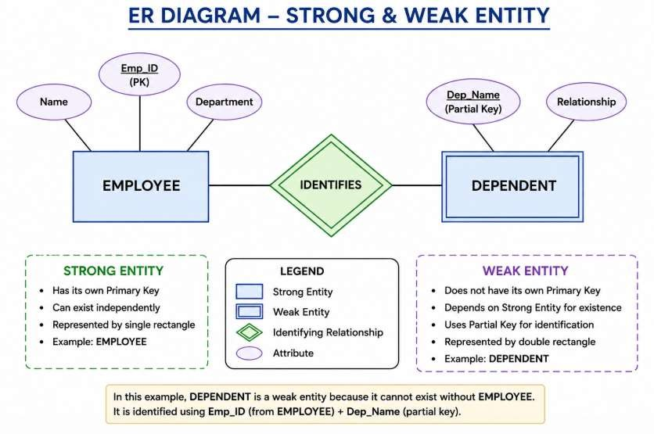
Question 9- Strong Entity vs Weak Entity



Question 10- Retail Chain Management System (EER Model)

A Retail Chain Management System helps manage stores, products, customers, employees, and sales. The EER Model extends the ER model by using Generalization and Specialization, making the database easier to organize and manage.

Main Entities
  - Person (Superclass)
Benefits
- Reduces data redundancy.
- Organizes customer and employee
information.
- Improves database efficiency.
- Simplifies retail management
  - Customer (Subclass)
  - Employee (Subclass)
  - Product
  - Store
  - Sale

Generalization & Specialization
  - Person is the Superclass.
  - Customer and Employee are Subclasses that inherit common attributes from Person.



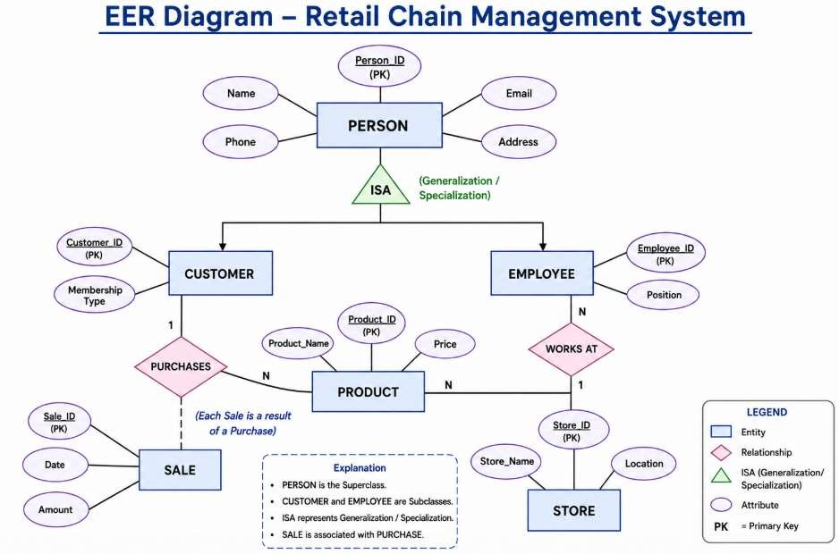
Question 10- Retail Chain Management System (EER Model)




